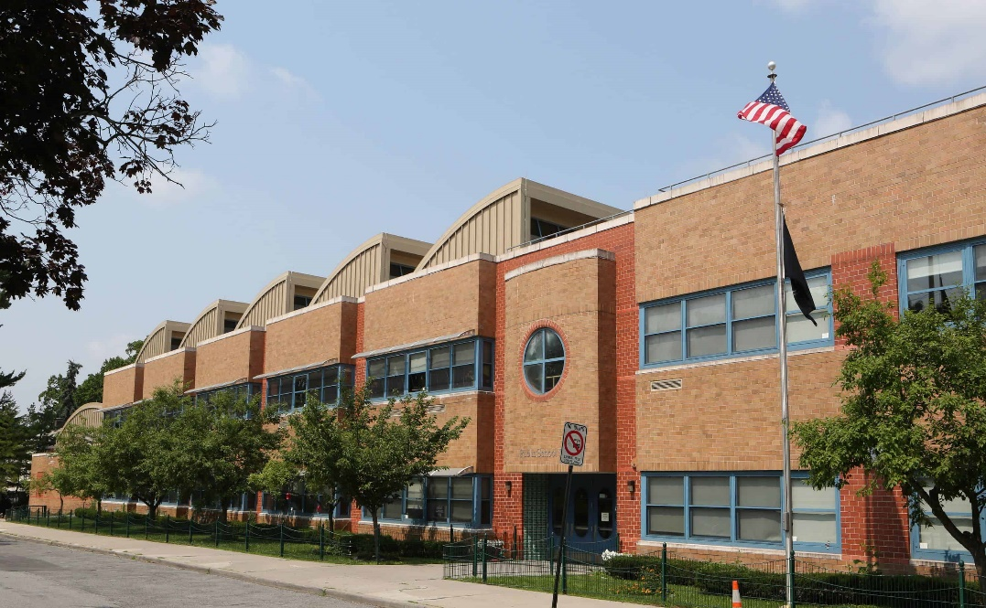

MINIMUM CAPACITY :-

The Minumum intake capacity

of students is between 300-620

children

LIBRARY :-

The Libarary is Available.

CANTEEN:-

The Canteen Facility is Available.

BOARDING :-

No availablility of boarding.

SPORTS :-

There are different categories

sports available.

Girls Volleyball

Boys Volleyball

Football

|  |  |  |
| --- | --- | --- |
| PAIDEIA SCHOOL 15  YONKERS - SCHOOL |  |  |
|  |  |  |
| School Detail :- Paideia School 15 is a magnet school located in Yonkers, NY, which is in a large suburb setting. The student population of Paideia School 15 is 559 and the school serves PK-8. At Paideia School 15, 48% of students scored at or above the proficient level for math, and 34% scored at or above that level for reading.  . At Paideia School 15, 48% of students scored at or above the proficient level for math, and 34% scored at or above that level for reading. |  |